Breathing Training Assistant
I'm going to make a wearable device to help college students decompress and practice breathing exercises. To prevent boredom during training, I also created a parkour game to help users relieve their emotions while training. I will use a Micro:bit and Python code to deeply restore the process of breathing training and, at the same time, realise the interactive function of small games.

Stage Record
September 8th - September 14th Creative Concept

I spent this week learning more about what breathing training is and the mode of breathing training. At the same time, we studied the hard conditions required for wearable devices. Considering the limited hardware and programming languages available now, it was finally decided to make a Micro:Bit device that uses only Micro:Bit microphones and an LED dot matrix. At the same time, considering that there is only Micro: Bit hardware, users can only be guided to breathe training by playing the bee when breathing. At the beginning, the idea for the game was to make two games: a parkour game and a gold-coin-eating game. However, due to hardware limitations, it was finally decided to make only a parkour game. The character in the game is selected as Mario. You can pause at any time during training. Touch the logo to switch between breathing training and game pattern. When examining the literature, it was found that the three most common types of breathing training are uniformity, decompression, and concentration improvement. This made me very interested in the whole breathing training and how to support it. At present, it is only in the conception stage. The overall progress schedule is stable, and the concept is ready to be gradually realised. At the same time, we will use sophisticated algorithms to perform various operations. I originally planned a difficult project, but when I considered the feasibility, I found it was a little too much, and I still felt I needed to do what I could.

September 14 - September 7 Stage 1 - Conception and Design of Breathing Training
After the methodical conception, I made a list of plans. At this stage, I developed three modes: breathing, relaxation and decompression, and concentration-enhancement. And conceived a complete set of training logic.
1.Normal: inhale for 4 seconds, exhale for 4 seconds
2. Relax: inhale for 4 seconds and exhale for 6 seconds
3. Focus: inhale for 6 seconds, exhale for 4 seconds

Based on the whole complete breathing logic, I decided to use an LED dot matrix and auditory effects. Allow users to train correctly according to patterns and sounds. Users can follow the breathing training guidelines freely to complete the training. It is assumed that users can terminate training at any time and report the number of completions. Users need to maintain a breathing rhythm throughout the whole process, which is a bit like meditation. This means that the scene used is not single, but suitable for training in different scenarios. It can reduce stress while studying and help you sleep before going to bed.

I encountered a type error when making breathing exercises. Because the plus sign can only be added to the same type, and the display can only display the character type. So finally, through type conversion.
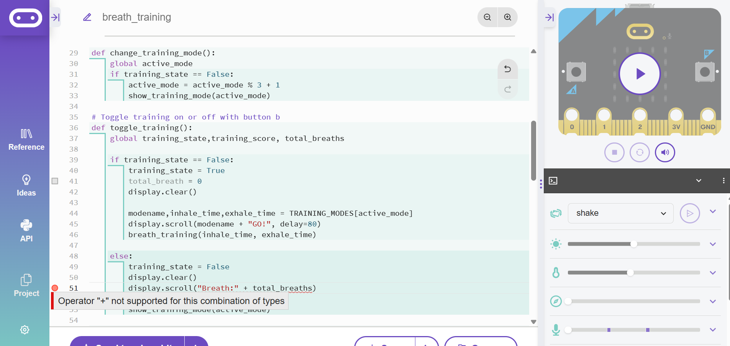

September 8 – October 5 Phase 2 – Game Design
At first, I considered making two games: a parkour game and a gold-coin-eating game. Due to the limitations of the display area, it was decided to run a Free Run to avoid obstacles. The previously conceived gold coin-eating game will be constrained by the inability to display the screen, and cannot make a scroll-like effect. All game experiences will be very good. When designing the game, considering that users will want to enter the game faster, it is necessary to let users calm down first. Slowly rolling subtitles can calm them down. In the next stage, the game code will be merged, and the final finishing and testing will be completed.

The reason why line 61 reports an error is that when jumping up, the coordinates of Y gradually decrease and become a negative value. The error report crosses the line. The minimum is 0, which cannot be negative.
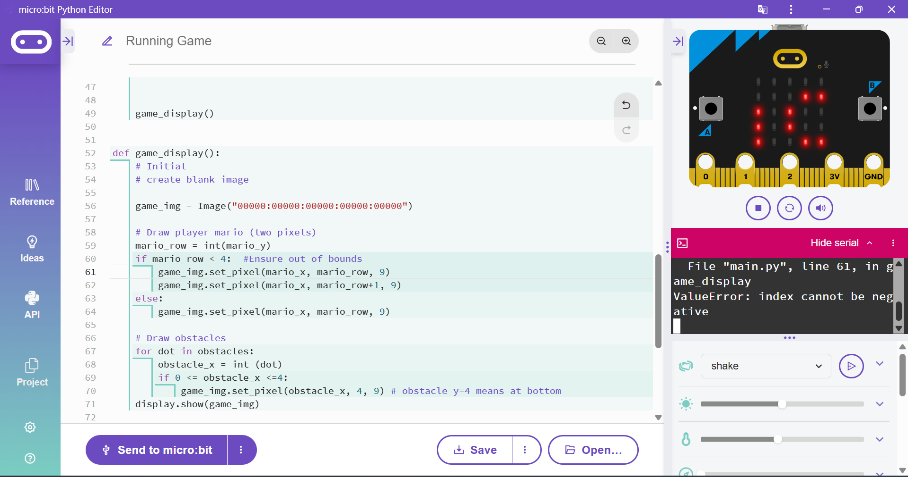

October 5th - October 24th Switch pattern design, operation detection

At this stage, I set up the complete running logic and implemented all the algorithms. Finally, I started running the code. At this stage, I debugged and merged the code, then started testing, and it ran perfectly. However, it should be noted that the next button cannot be used when the scrolling subtitles are not fully displayed. This may be the underlying operational logic of Micro:Bit.

When merging the code, the corresponding method could not be found because it had training_start, which was mistakenly spelled training. The problem was found during testing and resolved.

